

CAPSTONE PROJECT REPORT
Report 1 – Project Introduction

– Da Nang, Sep 2026 –

Table of Contents
- Record of Changes 2
- Project Introduction 3
  - Overview 3
    - Project Information 3
    - Project Purpose 3
    - Project Stakeholders 3
  - Product Background 3
    - Current Market Trends 4
    - Current Market Problems & Limitations 5
    - Project Context and Motivation 6
  - Existing Systems 7
    - Deskpass 7
    - Spacesworks 8
    - Robin 9
  - Business Opportunity 11
    - Market Opportunity 11
    - Unresolved Business Problems 11
    - NexSpace Value Proposition 12
    - Competitive Advantages 12
    - Business Potential 12
  - Software Product Vision 13
    - Key System Features 13
    - Project Vision and Scope 13
    - Cost-Saving Development Approach 14
  - Project Scope & Limitations 15
    - Major Features 15
    - Limitations & Exclusions 17

Record of Changes

Date | A* / M, D | In charge | Change Description
13/08/26 | A | HuyMD | Create the report template for Report 1: Project Introduc-tion.
13/08/26 | A | HuyMD | Add content to Section II, Part 1.2
13/08/26 | A | VuNH | Analysis and synthesis of Section II, Part 2
13/08/26 | A | PhongTH | Check and complete Section II, Part 1.3
13/08/26 | A | HienHM | Add content to Section II, Part 1.1 - Project Information
16/08/26 | M | KhoaNKD | Modify Records
16/08/26 | M | KhoaNKD | Modify 1.1 Project Information
16/08/26 | M | KhoaNKD | Modify 2. Product Background ver 1
26/08/26 | A | HuyMD | Add content to Section II, Part 4
26/08/26 | M | KhoaNKD | Modify 2. Product Background ver 1.1
26/08/26 | A | HienHM | Add content to Section III, Part 3.3 - Existing System: Robin
26/08/26 | A | VuNH | Added Section 3.1 - Deskpass to Existing Systems.
26/08/26 | M | VuNH | Modified content for Deskpass in Section 3.1 - Existing Sys-tems
26/08/26 | M | KhoaNKD | Modify content to Section II, Part 4
26/08/26 | A | KhoaNKD | Added Section 6.2 Limitations & Exclusions
26/08/26 | A | HuyMD | Add content to Section II, Part 6.1
27/08/26 | M | KhoaNKD | Modify 2. Product Background ver 1.2
27/08/26 | M | KhoaNKD | Modify 5.2 Project Version and Scope
27/08/26 | M | KhoaNKD | Modify 5.3 Cost-Saving Development Approach
27/08/26 | M | KhoaNKD | Align text margins

*A - Added M - Modified D - Deleted

Project Introduction

Overview

Project Information
- English name: Build of an AI-Integrated Platform for Optimizing the Coworking Space Reservation Process
- Vietnamese name: Xây dựng Nền tảng tối ưu quá trình đặt chỗ Không gian Làm việc Chung có tích hợp AI

Project code: NS
- Group name: SE_31
- Software type: Mobile Application - Web Application

Project Purpose
The purpose of this project is to develop NexSpace, an AI-integrated coworking space booking plat-form that connects Customers, Organizers, and Administrators. NexSpace is designed to support workspace discovery, real-time seat availability, workspace booking, online payment through PayOS, QR code check-in, floor plan and seat management, notifications, reviews, financial management, and AI-powered workspace recommendations. The platform aims to reduce double booking, improve workspace utilization, simplify operational and financial management for Organizers, and provide Customers with a secure, transparent, and convenient booking experience. This document serves as a guideline for the project’s objectives and the implementation of its major functions.

Project Stakeholders

Full Name | Role | Email | Mobile
Nguyen Phuong Tam | Lecturer | TamNP4@fe.edu.vn | 0862317831
Mai Huy Minh | Mentor | MinhMH1@fpt.com
Nguyen Kim Dang Khoa | Leader | khoankdde180292@fpt.edu.vn | 0869871509
Mai Dang Huy | Member | huymdde180293@fpt.edu.vn | 0395836625
Nguyen Huy Vu | Member | vunhde180288@fpt.edu.vn | 0899891697
Hoang Minh Hien | Member | hienhmde180291@fpt.edu.vn | 0903564303
Tran Hong Phong | Member | phongthde180299@fpt.edu.vn | 0787649263

Table II-1.3 Project Team

Product Background

Current Market Trends
The landscape of modern work is undergoing a significant transformation, shifting away from rigid cor-porate structures toward highly adaptable environments. As hybrid work models, freelancing, startup ecosystems, and remote working arrangements continue to experience explosive growth, the demand for flexible workspaces has reached unprecedented levels.
- The Rise of Hybrid Work: According to recent global workforce reports by McKinsey and Gallup, over 50% of modern enterprises have permanently adopted hybrid work policies. This shift has driven companies to decentralize their offices, seeking localized, on-demand workspaces for their distributed teams rather than maintaining large, underutilized headquarters.
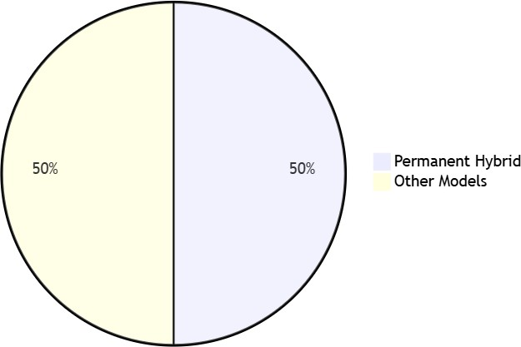

Figure II-2.1. Percentage of enterprises adopting Hybrid Work (McKinsey & Gallup)

- Coworking Market Growth: The “Space-as-a-Service” (SPaaS) model is booming. Industry analytics (such as reports from Statista and CBRE) project the global coworking space market to exceed $34 billion by 2026, growing at a Compound Annual Growth Rate (CAGR) of over 15%.
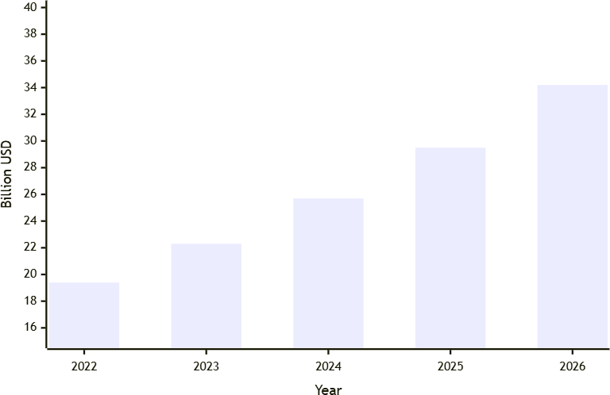

Figure II-2.2. Projected Global Coworking Market Size to 2026 (Statista & CBRE)

- Community and Networking Needs: Coworking spaces have evolved beyond mere alternatives to traditional offices; they are now essential hubs that foster community, collaboration, and profes-sional flexibility. Independent workers and startups increasingly rely on these spaces to combat the

isolation of working from home and to unlock B2B networking opportunities.

Current Market Problems & Limitations
Despite the surging demand, the coworking space market currently suffers from a severe lack of digital synchronization. A significant portion of workspace providers—particularly independent or mid-sized operators—still rely on manual, traditional, or fragmented software processes (e.g., using a mix of Ex-cel spreadsheets, Google Forms, and disconnected messaging apps) to manage daily operations. This technological lag leads to critical pain points across all stakeholders:

For Customers (End-Users):
  - High Friction in Discovery & Booking: Users face significant hurdles in finding workspaces that meet their specific needs (e.g., quiet zones, podcast rooms, or team pods). Surveys indicate that users often waste up to 30-45 minutes cross-referencing platforms just to check real-time seat availability.
  - Poor User Experience: Cumbersome manual booking and payment procedures, lack of trans-parent pricing, and inability to view physical space layouts beforehand lead to high drop-off rates during the reservation process.

For Space Organizers (Space Owners):
  - Inefficient Resource Management: Organizers are burdened with manually managing bookings and static floor plans. Industry benchmarks reveal that spaces relying on manual management typically suffer from a 20-30% lower spatial utilization rate.
  - Operational Errors & Revenue Leakage: Manual operations frequently lead to human errors, such as double-booking conflicts and missed invoice tracking. Furthermore, organizers face heavy administrative burdens in accurately monitoring daily revenue, processing refunds, and managing payouts, which can account for up to 15 hours of wasted administrative time per week.

For Platform Administrators:
  - Fragmented Ecosystems: Without a unified management dashboard, administrators struggle to oversee system-wide transactions, calculate dynamic commissions, and handle user disputes. Managing activities scattered across different operational processes makes it nearly impossible to generate accurate data-driven reports or scale the business efficiently.
- Overall Impact: These collective issues ultimately result in a frustrating customer experience, wasted spatial resources, and highly inefficient, costly business operations.

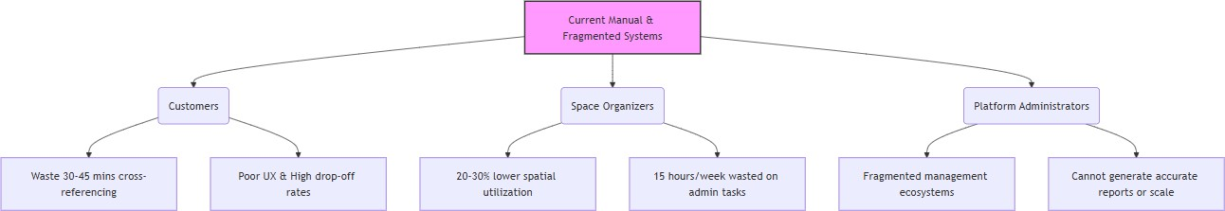

Figure II-2.3. Operational pain points across stakeholders in the current coworking market

Project Context and Motivation
The concept for NexSpace was proposed by our student development team as a direct, technologically driven response to the aforementioned market limitations. To bridge the widening gap between the surging customer demand for flexible work environments and the inefficient operational processes of space providers, the team aims to build NexSpace: An AI-Integrated Platform for Optimizing the Cowork-ing Space Reservation Process.
By developing NexSpace, the project aims to digitize and automate the entire lifecycle of workspace booking. The platform is motivated by the following core objectives:
- AI-Powered Personalization: Implementing machine learning algorithms to analyze user prefer-ences, past bookings, and work habits to provide highly personalized workspace recommendations and predictive demand forecasting for organizers.
- Real-Time Interactivity: Introducing real-time availability tracking combined with interactive, visual floor plan management, allowing users to select their exact preferred seat—much like booking a movie theater ticket.
- End-to-End Automation: Integrating secure, frictionless payment gateways and automated revenue tracking to eliminate manual financial reconciliation.

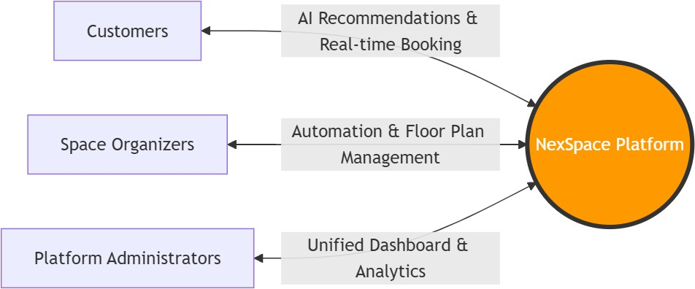

Figure II-2.4. The NexSpace ecosystem and value propositions for stakeholders

Conclusion of Motivation: NexSpace is not just a booking tool; it is a comprehensive ecosystem. By eliminating manual redundancies and optimizing spatial resource allocation, NexSpace aims to increase workspace utilization by an estimated 25-30% while reducing administrative overhead. Ultimately, it will deliver a seamless, transparent, and modern experience that empowers customers, enriches workspace organizers, and streamlines platform administration.

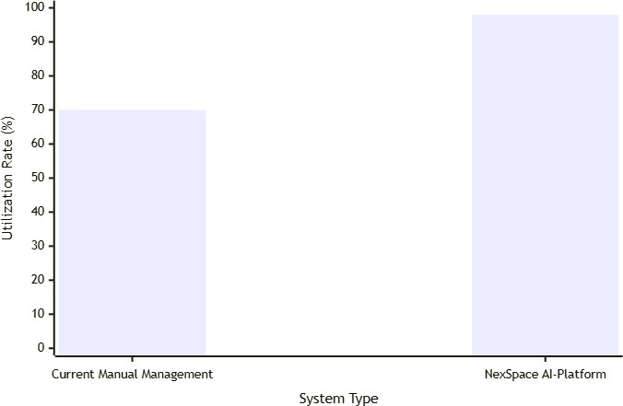

Figure II-2.5. Expected Improvement in Spatial Utilization with NexSpace

Existing Systems

Deskpass
Link: https://www.deskpass.com/
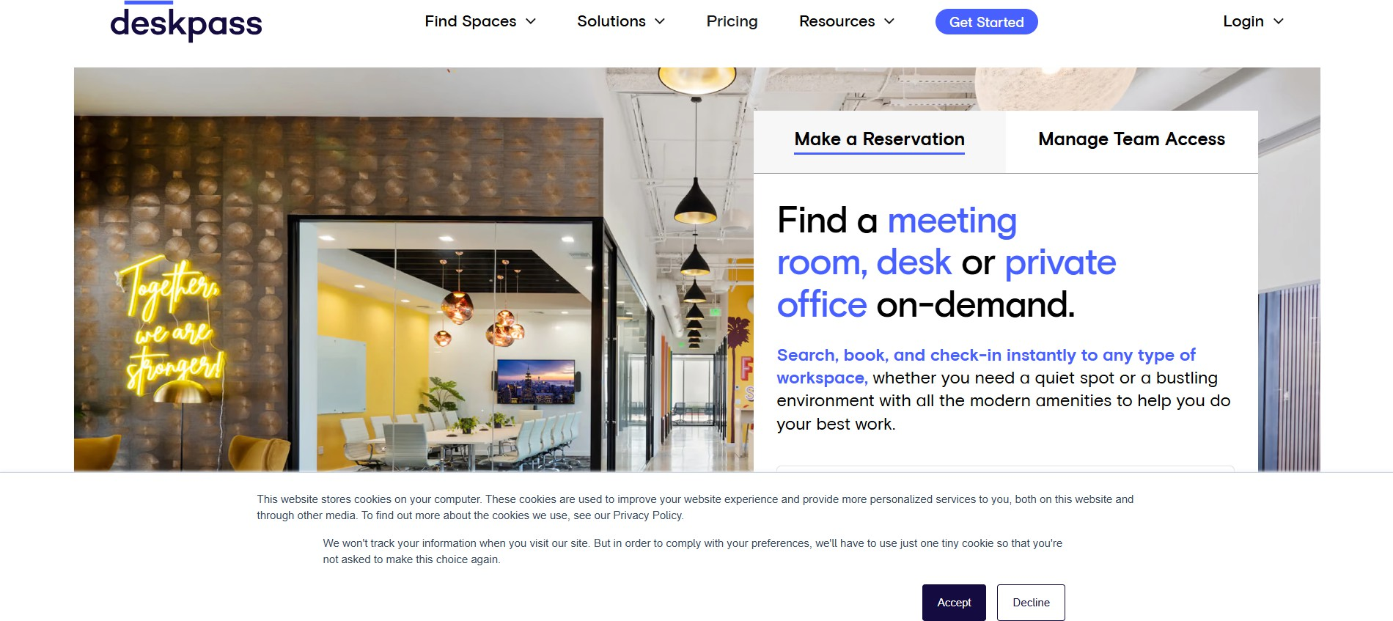

Figure II-3.1. Deskpass Homepage

Deskpass is a coworking space booking platform that allows customers to discover and reserve cowork-ing spaces. It provides workspace search, filtering, availability checking, booking, and workspace listing management.

Actors:
- Customer
- Workspace Provider
- Platform Administrator

Main features:
- Search and filter coworking spaces
- View workspace information and availability
- Book workspaces
- Manage reservations
- Manage workspace listings

Pros:
- Simple workspace discovery and booking process.
- Connects customers with multiple workspace providers.
- Provides a useful reference for workspace availability and booking workflows.

Cons:
- Its main focus is workspace discovery and reservation, while NexSpace has a broader scope including AI features, seat-level management, floor plan management, and marketplace administration.

Lessons Learned / Application to NexSpace:
- Deskpass provides a good reference for designing a simple and user-friendly workspace discovery and booking workflow. NexSpace can apply this approach while extending it with real-time seat availability, interactive floor plans, AI-powered recommendations, and integrated payment man-agement to provide a more comprehensive booking experience.

Spacesworks
Link: https://www.spacesworks.com/vi
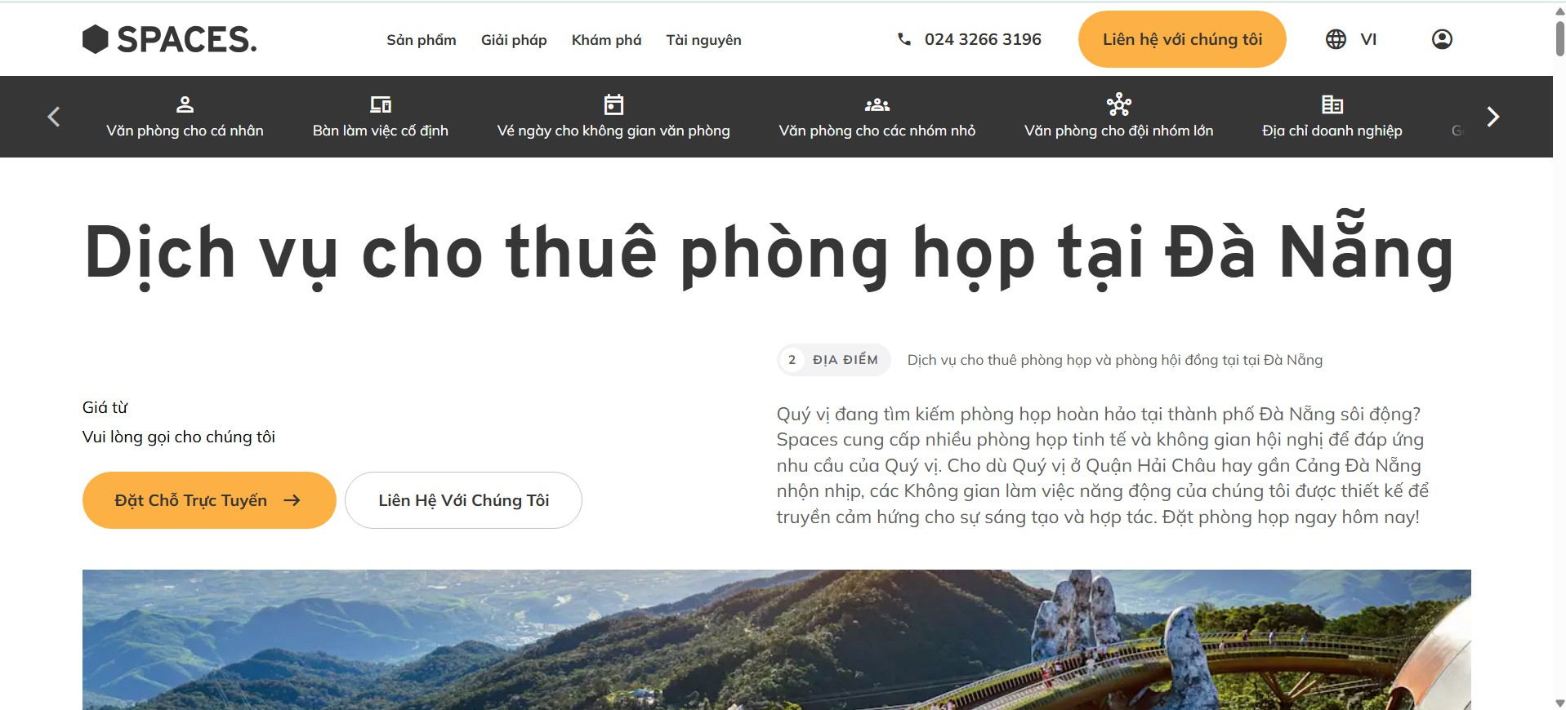

Figure II-3.2. Spaceworks Homepage

Spacesworks allows users to find and book flexible workspaces, including meeting rooms, offices, dedicated desks, coworking passes, and virtual offices. Its centralized Workplace Portal streamlines workspace management through real-time bookings, flexible plans, and on-site support.

Actors:
- Customer
- Workspace Provider
- Platform Administrator

Main features:
- Search and filter workspaces by location, type, and amenities
- View workspace details, prices, and available times
- Book meeting rooms, desks, and offices
- Manage bookings and service plans
- Manage space listings, calendars, and guest services

Pros:
- Easy to search and book workspaces for hours or days.
- Connects users with different workspace locations easily.
- Optimizes the booking workflow for quick check-ins.

Cons:
- Focus on features that Spacesworks lacks, such as interactive floor maps, seat-level management, and AI recommendations to create a competitive advantage.
- Lacks advanced features compared to NexSpace, such as AI suggestions, interactive floor maps, and seat management.

Lessons Learned / Application to NexSpace:
- Keep the search and booking process simple, fast, and frictionless for daily or hourly users.
- Focus on features that Spacesworks lacks, such as interactive floor maps, seat-level management, and AI recommendations to create a competitive advantage.
- Provide flexible booking management tools that allow users to easily update or reschedule existing bookings within the allowed time frame.

Robin
Link: https://robinpowered.com/platform/desk-booking

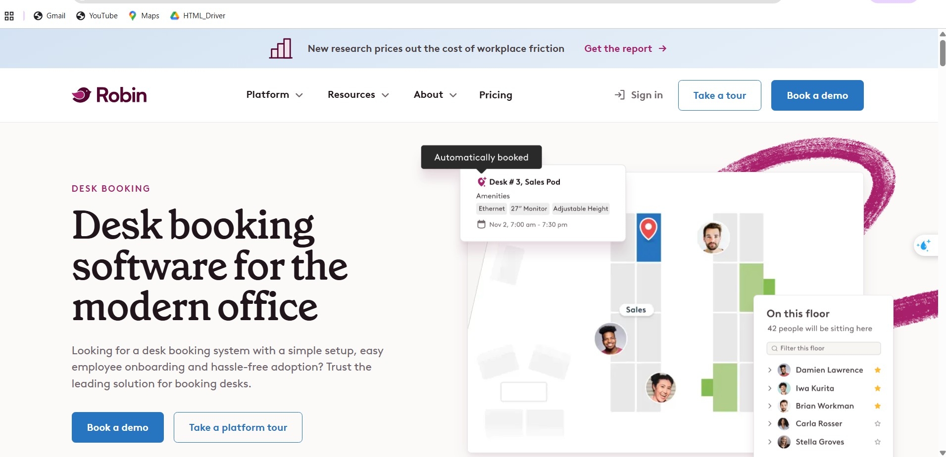

Figure II-3.3. Robinpowered Homepage

Robin is a workplace management and desk booking platform that helps users find, reserve, and man-age desks and other workplace resources. It provides interactive office maps that allow users to view real-time desk availability and select a specific desk directly from the floor plan. Robin also supports desk management, floor plan configuration, multi-day booking, check-in, and workplace analytics. In addition, its automatic desk booking feature can use users’ past bookings, preferences, and preferred office locations to help select desks automatically.

Actors:
- Customer / Employee
- Workspace Administrator
- Platform Administrator

Main features:
- View available desks through an interactive floor map
- Select and book specific seats or desks
- Check real-time desk availability
- Filter desks by location, floor, and amenities
- Manage floor plans, desks, and seating layouts
- Support multi-day desk reservations
- Check in to reserved desks
- Analyze workspace usage and booking data
- Provide automatic desk booking based on user preferences and previous bookings

Pros:
- Provides an interactive floor plan that allows users to select a specific desk instead of booking from a simple list.
- Provides real-time visibility of available and occupied desks, making the seat selection process more intuitive.

- Supports detailed desk and floor plan management for workspace administrators.
- Its automatic desk booking feature provides a useful reference for implementing personalized or AI-assisted workspace recommendations.

Cons:
- Robin mainly focuses on workplace and office management rather than a multi-provider coworking marketplace.
- Its booking model is primarily designed for organizations managing their own workplaces, so it pro-vides less emphasis on discovering and comparing coworking spaces from different providers.
- Although Robin provides automatic desk booking and recommendation-related capabilities, NexS-pace can further adapt these ideas to provide AI-based workspace recommendations based on fac-tors such as users’ preferred location, budget, amenities, seat type, and usage purpose.
- NexSpace can also combine interactive floor plans and seat-level booking with a broader cowork-ing marketplace, allowing customers to discover different workspace providers and reserve specific seats within those spaces.

Lessons Learned / Application to NexSpace:
- NexSpace can learn from Robin’s interactive floor plan to provide users with a visual view of workspace layouts and available seats.
- The seat-level booking feature can be applied to allow customers to select and reserve a specific seat instead of booking only an entire workspace.
- Robin’s real-time availability can be referenced to improve the accuracy of seat availability during the booking process.
- NexSpace can extend Robin’s automatic booking and preference-based features by integrating AI-powered workspace recommendations based on users’ preferred location, budget, amenities, seat type, and usage purpose.
- NexSpace can combine these features with its coworking marketplace, allowing customers to dis-cover different workspace providers, compare spaces, and reserve specific seats through an inter-active floor plan.

Business Opportunity

Market Opportunity
The growth of hybrid work, remote working, freelancing, and startup communities has increased the demand for flexible workspaces. Customers increasingly need a convenient way to discover, compare, and reserve coworking spaces. At the same time, workspace organizers need digital tools to manage their spaces, reservations, and financial activities more efficiently. These needs create an opportunity for a centralized coworking space marketplace such as NexSpace.

Unresolved Business Problems
Current coworking space booking and management processes are often manual or fragmented. The main unresolved problems include:

- Customers cannot easily check real-time availability at the individual seat level.
- Customers must use separate or manual processes for booking, payment, and check-in.
- Organizers may encounter booking conflicts and inefficient workspace utilization.
- Organizers have difficulty managing floor plans, seats, reservations, revenue, refunds, and payouts.
- Administrators lack a centralized system for managing transactions, commissions, disputes, and marketplace activities.
Without an integrated platform, these problems result in an inconvenient customer experience, opera-tional errors, inefficient use of workspace resources, and increased administrative workload.

NexSpace Value Proposition
NexSpace addresses these problems by providing a unified platform for customers, workspace organiz-ers, and administrators.
For customers, NexSpace offers AI-powered workspace recommendations, real-time seat availability, online booking, PayOS payment, QR code check-in, notifications, and reviews.
For organizers, the platform provides floor plan and seat management, reservation management, workspace availability control, and financial tracking.
For administrators, NexSpace centralizes user management, transaction supervision, commission calcu-lation, dispute handling, and marketplace administration.
As a result, NexSpace can make the booking process more convenient for customers while helping or-ganizers and administrators reduce manual work and manage their operations more effectively.

Competitive Advantages
Existing platforms such as Deskpass mainly focus on workspace discovery and reservation. NexSpace provides a more comprehensive solution by combining the following capabilities:
- AI-powered workspace recommendations.
- Real-time seat-level availability.
- Interactive floor plan and seat management.
- Integrated online payment and QR code check-in.
- Revenue, refund, payout, and commission management.
- Centralized marketplace administration.

These integrated capabilities allow NexSpace to support not only workspace booking but also the oper-ational and financial management of the entire coworking space marketplace.

Business Potential
NexSpace can generate revenue by receiving a commission from successful workspace reservations. As the number of customers, organizers, and listed workspaces increases, the platform can process more bookings without requiring a separate system for each organizer.

The product also aligns with current trends in flexible working, online marketplaces, digital payments, process automation, and AI-based personalization. Therefore, NexSpace has the potential to become a scalable platform that creates value for customers, workspace organizers, and platform administrators.

Software Product Vision

Key System Features
For customers who need convenient and flexible coworking spaces, NexSpace is an AI-integrated coworking space booking platform that connects Customers, Organizers, and Administrators through web and mobile applications. The system provides key features including workspace search and filter-ing, workspace information and real-time seat availability, workspace booking, online payment through PayOS, booking history, cancellation and refund requests, QR Code check-in, notifications, ratings and reviews, and favorite management. NexSpace also provides AI-powered workspace recommendations based on customer preferences, booking history, location, budget, and workspace type, together with an AI chatbot for workspace searching, FAQs, booking guidance, and customer support.
For Organizers, NexSpace supports workspace and facility management, image and gallery management, operating hour configuration, Drag & Drop Floor Plan management, seat and workspace configuration, real-time occupancy monitoring, booking and cancellation management, pricing and membership man-agement, revenue reporting, and booking notifications. Administrators can manage users and roles, approve or reject workspace providers, manage reports and disputes, configure platform rules, manage commission rates and transaction fees, and monitor platform activities and analytics.

Project Vision and Scope
The vision of NexSpace is to become the premier AI-integrated, centralized marketplace for coworking space discovery, reservation, and management. The system aims to disrupt the current fragmented and manual coworking booking processes by providing customers with real-time, interactive workspace vis-ibility and a frictionless booking experience, while empowering organizers to manage layouts, capacity, and revenue without heavy administrative overhead.
The scope of the project encompasses web and mobile applications supporting three main actors: Cus-tomers, Organizers, and Administrators. To deliver maximum value and address the critical market lim-itations identified, the project will implement the following core features:
- AI-Powered Discovery and Recommendations: Utilizing machine learning to analyze customer pref-erences, budget, and past booking behaviors to suggest the most suitable workspaces. This includes an AI Chatbot Assistant to guide users through FAQs and the booking process.
- Interactive Drag & Drop Floor Plan Management: Allowing organizers to visually map out their physical space, configure seat types (hot desk, private office, etc.), and monitor real-time occupancy.
- Real-Time Seat Availability & Transaction Locking: Ensuring that customers can view the exact availability of individual seats and lock them during the checkout process to absolutely eliminate double-booking conflicts.
- Integrated Online Payment (PayOS): Providing a seamless, secure, and automated payment gate-way for customers to complete reservations, while automating revenue and commission calcula-tions for organizers and admins.
- QR Code Check-in System: Automating the physical check-in process at the workspace, reducing

the need for front-desk staff and improving the customer experience.
- Comprehensive Organizer Dashboard: Centralizing the management of bookings, cancellations, membership pricing, and financial reporting (revenue, refunds, and payouts) to eliminate manual Excel or paper-based tracking.
- Centralized Platform Administration: Equipping platform admins with tools to govern user roles, approve/reject workspace providers, manage platform commission rates, and resolve transaction disputes efficiently.
The project is intended to provide a robust, scalable foundation focused on these core functionalities, ensuring a high-quality user experience before considering advanced hardware or IoT integrations in future expansions.

Cost-Saving Development Approach
Due to limitations in project time, budget, and development resources, NexSpace adopts a highly strate-gic, cost-saving approach that benefits both the development team and the end-user businesses (Orga-nizers).

Value for Businesses (Organizers) vs. Existing Systems
Currently, independent workspace organizers face steep financial barriers when digitizing their opera-tions. Proprietary software development costs tens of thousands of dollars. Meanwhile, subscribing to existing enterprise solutions like Robin or Spacesworks typically requires expensive, recurring per-desk or per-user monthly SaaS fees, which severely impacts the profit margins of small-to-mid-sized cowork-ing spaces.
NexSpace solves this by operating on a Pay-as-you-go / Commission-based Marketplace Model. Orga-nizers do not have to pay hefty upfront licensing fees or monthly software subscriptions to manage their floor plans. They only incur a platform commission fee when a successful booking is made. Furthermore, by automating manual tasks (booking reconciliation, payment tracking, floor plan management), NexS-pace directly reduces the estimated 15 hours per week of administrative labor, leading to significant human resource cost savings for the business.

Value for the Development Process
To build this robust ecosystem within a limited timeframe and budget, the project strictly avoids “rein-venting the wheel.” The team leverages established open-source technologies and cost-effective third-party services to minimize technical complexity and infrastructure costs (CAPEX):
  - Frameworks: ReactJS/TypeScript (Web) and Flutter (Mobile) enable cross-platform development with a single codebase, drastically reducing mobile development time and resources compared to native development.
  - Backend & Database: Java Spring Boot and MySQL provide highly scalable, free-to-use, and community-supported foundations.
  - Third-Party Integrations: Instead of building complex internal modules from scratch, the system integrates PayOS (for streamlined, low-fee local transactions), Cloudinary (for optimized media stor-age), and Better Auth (for secure, standard-compliant user authentication).
  - DevOps: Utilizing Git, GitHub, and GitHub Actions for CI/CD ensures automated testing and deploy-ment, minimizing costly manual server management and reducing downtime.

By adopting this Clean Architecture and modular integration approach, the team focuses its limited re-sources purely on generating core business value—specifically the AI recommendations and interactive floor plan mapping—ensuring a high-performance product at a fraction of traditional enterprise devel-opment costs.

Project Scope & Limitations
The project scope defines NexSpace as an AI-integrated, intermediary digital platform functioning across Web and Mobile applications. NexSpace does not own physical real estate; instead, it acts as a central-ized marketplace connecting independent and mid-sized coworking space businesses (Organizers) with end-users (Customers) such as freelancers, startups, and hybrid workers. The platform serves to digitize the booking process for specific physical locations provided by these partners. The scope is limited to software solutions that enable space discovery, interactive floor plan management, real-time seat reser-vation, online payments, and AI-powered recommendations. Clarifying these boundaries ensures real-istic expectations for all stakeholders—Customers, Organizers, and Administrators—while establishing a framework to evaluate future feature requests. Proposed requirements outside this digital, interme-diary scope will be rejected unless deemed beneficial enough to justify expanding the project’s budget and timeline.

Major Features
Figure II-6.1 provides an overview of the major features offered by NexSpace to its three primary actors: Customers, Organizers, and Administrators. The detailed features are described and identified by unique feature codes in the following subsections.
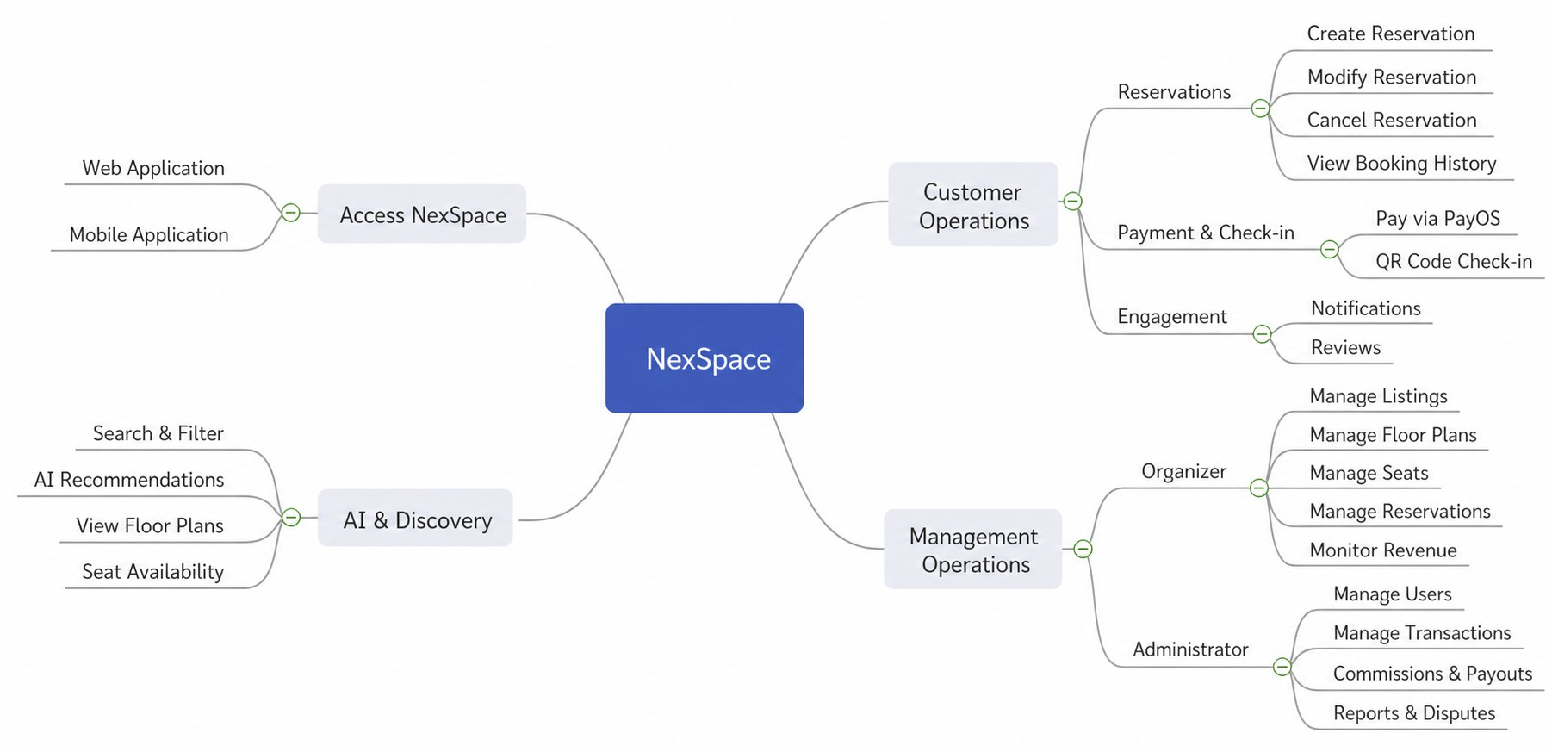

Figure II-6.1. NexSpace Major Feature Overview

The major features illustrated in Figure II-6.1 are described as follows:

Customer Features

FE-01: Workspace Discovery and Comparison

Allow customers to search, filter, and view coworking spaces based on criteria such as location, price, workspace type, available time, amenities, and customer ratings.

FE-02: AI-Powered Workspace Recommendations
Provide personalized workspace recommendations based on customer preferences, search behavior, and booking history. An AI chatbot also assists customers in searching for workspace information and receiving basic support.
FE-03: Interactive Floor Plan and Seat Availability Allow customers to view interactive floor plans and check the availability of individual seats or workspace areas before making a reservation.

FE-04: Workspace Reservation Management
Allow customers to create, view, modify, and cancel workspace reservations. The system applies reser-vation locking and availability validation to reduce booking conflicts and double-booking.
FE-05: Online Payment and Refund Tracking Allow customers to pay for reservations through PayOS and view the status of their payments and eligible refunds.

FE-06: QR Code Check-in
Generate a QR code for a confirmed reservation and allow customers to use it for software-based check-in at the booked coworking space.

FE-07: Notifications and Reviews
Notify customers about booking confirmations, payment results, cancellations, refunds, and upcoming reservations. Customers can also rate and review a workspace after completing a reservation.

Organizer Features

FE-08: Workspace Listing Management
Allow organizers to create, update, publish, temporarily disable, and manage coworking space listings, including workspace descriptions, images, amenities, operating hours, policies, and pricing information.

FE-09: Floor Plan and Seat Management
Allow organizers to create and manage digital floor plans, workspace areas, individual seats, seat types, and their availability status.

FE-10: Reservation and Check-in Management
Allow organizers to monitor reservations, verify customer check-ins, manage booking statuses, and con-trol seat availability for specific time slots.
FE-11: Financial Management Provide organizers with dashboards and records for monitoring booking revenue, platform commissions, refunds, and payout status.

Administrator Features

FE-12: User and Workspace Administration

Allow administrators to manage customer and organizer accounts, review workspace listings, and con-trol content or accounts that violate platform policies.

FE-13: Marketplace and Transaction Administration
Allow administrators to supervise reservations, payments, refunds, commissions, and payout records across the platform.

FE-14: Reports and Dispute Management
Allow administrators to receive and process reports or disputes related to platform bookings and trans-actions in accordance with NexSpace policies.

Limitations & Exclusions
To ensure realistic expectations among all stakeholders and maintain the feasibility of the project within the designated time and budget constraints, the following features and characteristics are explicitly excluded from the current scope of the NexSpace project:

Hardware and IoT Integrations

  - LI-01: No Smart Building / IoT Integration: Although the system supports a QR Code Check-in feature for workspace access, it does not integrate directly with physical Internet of Things (IoT) devices at the coworking spaces. Features such as syncing with automated smart locks, digital turn-stiles, lighting controls, or temperature management systems are out of scope.
  - LI-02: Purely Software-Based: NexSpace acts strictly as a digital platform (Web and Mobile appli-cations). The project team will not provide, install, or maintain any hardware equipment (such as check-in kiosks or physical scanners) for the Organizers.

Financial and Payment Limitations

  - LI-03: Single Payment Gateway: All online payments and financial transactions within the plat-form are exclusively processed through the PayOS gateway. Integration with other popular domes-tic or international payment providers (e.g., VNPay, MoMo, ZaloPay, Stripe, or PayPal) is not sup-ported in this current release.
  - LI-04: No Offline Cash Management: The system is designed to automate and manage digital cash flows via PayOS. It does not provide mechanisms to track, reconcile, or manage physical cash payments made directly at the Organizer’s front desk.

Business Model and Operational Boundaries

  - LI-05: Non-Ownership of Physical Assets: NexSpace functions solely as an intermediary digital marketplace connecting Customers and Organizers. The platform does not own, lease, insure, or bear physical responsibility for any real estate or coworking spaces listed on the system.
  - LI-06: Focus on Flexible / Short-term Bookings: The platform is specifically optimized for flexible coworking arrangements, such as hourly, daily, or specific membership packages. It does not sup-port complex, long-term traditional real estate leasing contracts (e.g., multi-year corporate leases) or residential rentals.

  - LI-07: Dispute Resolution Boundaries: While Administrators have a dashboard to handle reports and disputes digitally, the platform only mediates software-related issues (e.g., refund processing based on platform policy). NexSpace does not provide legal arbitration for physical damages, theft, or personal conflicts occurring at the physical coworking spaces.

AI and Technical Exclusions

  - LI-08: Scope of AI Capabilities: The AI integration is strictly focused on analyzing user preferences and booking history for workspace recommendations, as well as providing an AI Chatbot for search and customer support. Advanced generative AI features—such as automatically generating 3D floor plans or dynamically adjusting seat pricing in real-time (Dynamic Pricing AI)—are excluded.
  - LI-09: Real-time Dependency: NexSpace relies entirely on cloud-based synchronization for real-time seat availability and transaction locking. Consequently, the system requires a continuous in-ternet connection; it does not support an “offline mode” for users to book or organizers to manage layouts without network access.

